UVC Sterilizer Box

Item Name | Product Picture | Speficiations | Wireless Charging | Exw Price 1000pcs
XD-990 | 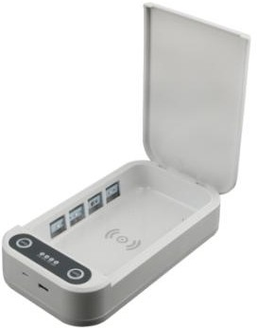 | Size：218*123*53MM Inner size：180*100*22MM UVC wavelength: 253.7mm UVC lamp power：2*1W Input：DC5V  Power：9W  N.W.: 340g, G.W.: 440g  Packing box： 27x17x6cm  Carton size：36pcs/carton,49.5x39.5x30cm G.W.：7.98KG / N.W.：6.97KG | No | US$12.35
 |  |  | Yes | US$13.75
X7 | 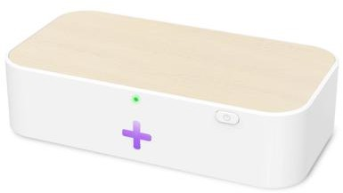 | Input:9V/2A  Ouput:wireless charger 15W/10W/7.5W UVC raidator Power :0.6W  UVC wavelength: 275-280nm  Recommend Operating temperature :0-40℃ Time for disinfection:≥10s/time  Material: ABS+PC  Product size: 170*91*41 mm  Package size: 177*99*48 mm N.W:174g/G.W: 334g  Carton:36x51x21cm, 40pcs/carton,14kgs | Yes | US$16.40
OJD-L02 | 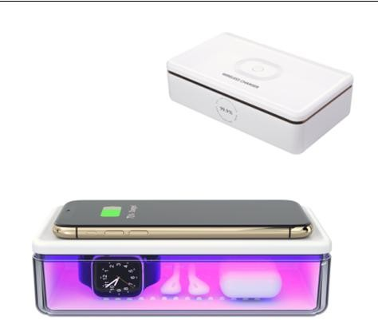 | Input: 5V/2A,9V/2A  Output: 5W 7.5W 10W 15W  Conversion efficiency:≥78% Charging distance: ≤6mm Dimension outside:53*114*196mm, inside:40*100*182mm Weight:338g  Color:white Material: PC+ABS UVC led: 9pcs  Working frequency:100-205KHZ UV Output:3W 700*455*280mm  Carton: 700*455*280mm, 40pcs/carton,17.7kgs | No | US$18.20
 |  |  | Yes | US$20.70
OJD-L03 | 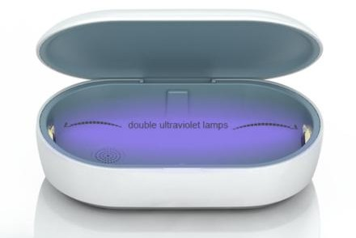 | Input: 5V/2A,9V/2A Output: 5W 7.5W 10W  UVC wavelength: 253.7mm Conversion efficiency:≥78% Charging distance: ≤6mm Dimension: 212.5x120x44mm  N.W.: 360g  G.W.: 615g Material: PC+ABS  Packing: 30pcs/ctn, 49x47x37cm/19.6kgs | Yes | US$23.85
OJD-L05 | 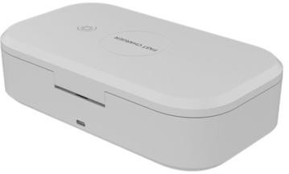 | Input: 5V/2A,9V/2A Output: 5W 7.5W 10W  UVC wavelength: 253.7mm Conversion efficiency:≥78% Charging distance: ≤6mm Dimension: 210x120x62mm  N.W.: 400g  G.W.: 643g Material: PC+ABS  Packing: 30pcs/ctn, 49.2x48x34.5cm/20kgs | Yes | US$18.80

Remarks:
1)Ready to ship in neutral packing 2)Production time: 5-7 days depends on qty 3)Payment term:TT in Advance.
4)Price terms: EXW 5)Certificate: CE,RoHS, FCC

